F
___________________________________________________________________________
Fay, Theodore Sedgwick (1807–1898)
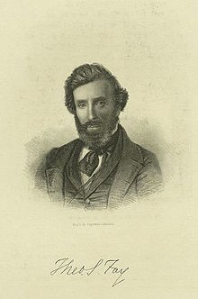
Parents: Joseph Dewey Fay (1779–1826) and Caroline Broome (1780–1816).
Married: (1) Laura Maria Gardinier (1806–1856); (2) Elizabeth Anne Leutwein.
Children: Elizabeth Martha Fay (1862– ) and Theodore Sedgwick Fry (1870– ).
Kinship: Husband of the great-granddaughter of the sixth great-granduncle of the post–World War II Smith generation.
Early Life and Career:
Theodore Sedgwick Fay was an American writer and diplomat who spent much of his life in Germany. Initially trained in law, he worked as a clerk for his father, an attorney, and was admitted to the bar in 1828. However, his literary inclinations soon led him to journalism. He became editor of the New York Mirror in 1828, where his essays were later collected as Dreams and Reveries of a Quiet Man (2 vols., 1832).
Diplomatic Service:
In 1837 Fay entered the U.S. diplomatic service, serving as secretary of the legation in London and later in Berlin (1837–1853). From 1853 to 1861 he was U.S. Minister to Switzerland. During his tenure he produced an influential memorandum, Denkschrift betreffend die Zulassung der nordamerikanischen Israeliten zur Niederlassung in der Schweiz (1859), advocating for Jewish emancipation. The report, prepared under the guidance of Rabbi Moïse Nordmann, contributed to the eventual Swiss reforms of 1866. Fay retired from diplomatic service in 1861 and settled in Berlin, where he lived until his death.
His Works:
• Views in New-York and Its Environs, from Accurate, Characteristic & Picturesque Drawings (New York: Peabody & Co., 1831), with James H. Dakin – engravings with commentary.
• Dreams and Reveries of a Quiet Man (2 vols., 1832) – essays originally published in the New York Mirror.
• Norman Leslie: A Tale of the Present Times (2 vols., 1835) – a best-selling novel, later dramatized by Louisa H. Medina; subject of Edgar Allan Poe’s scathing review.
• Sydney Clifton (1839).
• The Countess Ida (1841) – a didactic novel condemning dueling.
• Hoboken, a Romance (1843) – another anti-dueling work.
• Ulric: A Poem (1851) – explores the influence of Lutheranism on a German officer.
• Views of Christianity (1856).
• Die Sklavenmacht: Blicke in die Geschichte der Vereinigten Staaten von Amerika (“The Slave Power: A Look into the History of the United States of America,” Berlin, 1865) – a defense of the Union cause.
• A Great Outline of Geography (2 vols., 1867) – a school textbook.
• Die Alabama-Frage (“The Alabama Question,” Leipzig, 1872) – on the post-Civil War international dispute.
• First Steps in Geography (1873) – a geography primer.
• The Three Germanys (2 vols., 1889) – political and cultural history.
• History of Switzerland (n.d.).
Later Life:
Fay lived out his later years in Berlin. His long diplomatic service, coupled with his prolific literary career, made him one of the notable American expatriates in 19th-century Europe.
___________________________________________________________________________
Fenno Family
The Fenno family were an established and prosperous New England lineage, prominent from the eighteenth through the nineteenth centuries in Boston, Milton, and later New York. Their wealth derived from mercantile and publishing ventures, especially in printing, journalism, and trade. Members of the family operated one of the early American printing houses—Fenno & Son—responsible for The Gazette of the United States, a Federalist newspaper founded by John Fenno (1751–1798), a close ally of Alexander Hamilton.
His descendants continued to enjoy affluence and cultural influence. The Fennos intermarried with other prominent families, including the Russells, Lymans, and Lawrences. By the nineteenth century, branches of the family engaged in banking, shipping, and real estate in New York and Boston. Their education, travel, and frequent association with Harvard and the Boston Athenaeum reflected their upper-class standing.
____________________________________________________
Fenno, Elizabeth Lanier (1916–1969)
Parents: Allen Blanchard Fenno (1889–1918) and Elizabeth Lanier Turnure (1892–1940).
Married: (1) Samuel Adams Clark (1910–1988); (2) Patrick Henry Walters (1911–1961); (3) Vernon L. Ambrose (1919–2006).
Children: With Veron Ambrose: Elizabeth Ann Ambrose (1946–2006).
Kinship: Wife of the first cousin once removed (Clark) of the post–World War II Smith generation.
Early Life and First Marriage:
Elizabeth Lanier Fenno, known socially as “Betty,” was the daughter of Allen Blanchard Fenno and Elizabeth Lanier Turnure, and the stepdaughter of George K. Livermore, a wealthy and socially prominent New Yorker. She married Samuel Adams Clark in 1936 in the gardens of her mother’s Lenox, Massachusetts, estate. In 1940, after four years of marriage, she announced her intention to seek a divorce in Reno, Nevada—the fashionable “divorce capital” of the day.
The Reno Years and Marriage to the Cowboy:
In Reno, Betty joined the circle of Eastern socialites waiting out their six-week residencies. She purchased the historic Mayberry Ranch on the Truckee River for $60,000, later spending thousands more on renovations.
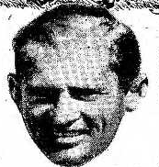
During this period, she met Patrick Henry (“Pat”) Walters, (right) a handsome cowboy and rodeo performer at the Washoe Pines Ranch, who quickly became her co According to the San Francisco Examiner (December 3, 1944), “The days with Pat were filled with fun and the nights with moonshine.” Walters, who could “tame wild horses but not women,” was widely admired in Reno’s dude-ranch society for his horsemanship and rugged charm. Gradually, one by one, the lone cowboy shortened the line sf suitors for Betty’s jeweled hand and heart and after a while he was the only one allowed in her corral. There he paid humble tribute to her beauty and charm in the manner of men form the Harold Bell Wright country.

He proposed and she accepted him on the spot. The stars over the cow country shone brighter. Heaven came very near. The pair married on December 29, 1942, after Betty returned to New York to secure her family’s approval.

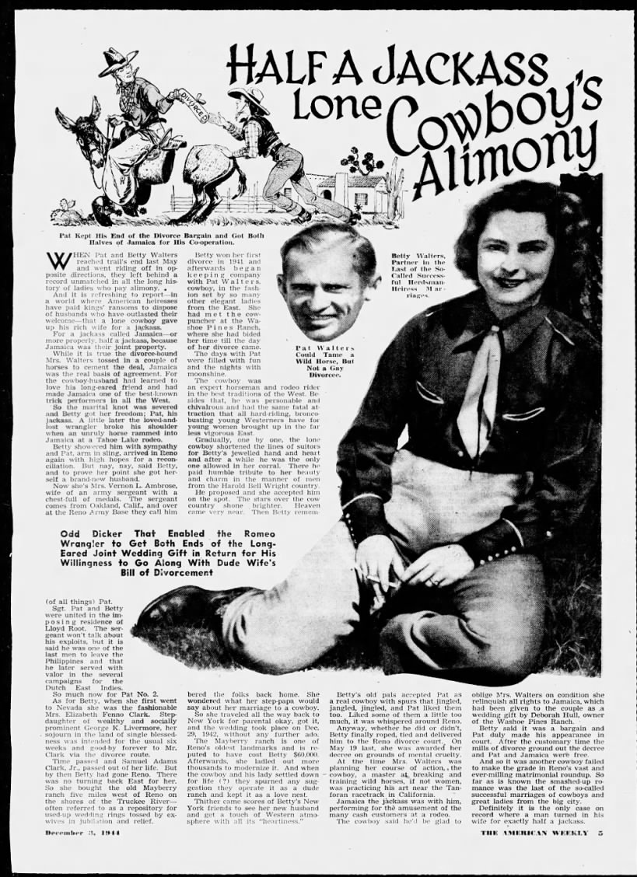

“When Pat and Betty Walters reached trial end last May and parted friends, Betty of El Paso divided the riding off her favorite animal, the jackass. And it is a very American story of law and love’s limitation—beginning over a wedding animal and ending with a divorce in Reno.
Betty Walters, now Mrs. Vernon L. Ambrose, gave up horses for jackasses—more precisely, half a jackass. While it was true the divorce court in Reno frowned on a dead-pan proposal for joint custody of the animal, it was true that Mrs. Walters promised Pat both halves if he’d cooperate with her divorce plan. Pat Walters could tame wild horses—but wasn’t a gay divorcée.
Betty was her first divorcee in 1931 and her second began in El Paso in 1943, keeping Pat in fashion with her plan to have the West’s most unusual divorce. Once the 1st Mrs. Walters had the P in Pat, the 2nd got the W in Walters. The P and W became the talk of the dude ranch set.
For the day of the divorce that finished the dude ranch evenings with Pat was at hand.
The cowboy was romantic and rode the range, and when he returned, the last of the long lines of saturnine ranch riders was ready to bow out. After a while he was the only man who could tell his wife’s will from her won’t. There’s a moral in the moment of western life for urban America—if there’s a Harold Bell Wright country, there’s also a Wright girl country where men go wrong. Thus Betty remounted her western dreams.”

It is always a bad sign when one’s marital troubles occupy a full newspaper page.
Their marriage soon unraveled. As the San Antonio Light (December 3, 1944) reported, “it is refreshing to report that a lone cowboy gave up his rich wife for a jackass.” The “jackass,” a donkey named Jamaica, had been given to the couple as a wedding present by Deborah Hull of the Washoe Pines Ranch. When Betty filed for divorce in 1944, Pat agreed to cooperate—on condition that she relinquish all rights to Jamaica. Betty agreed, and the court granted her a divorce on May 19, 1944, citing “mental cruelty.”
Aftermath and Later Life:
Following the divorce, Walters continued performing with Jamaica on the rodeo circuit until he broke his shoulder in an accident at Lake Tahoe. Although Betty offered sympathy, there was no reconciliation. Within months, she married Sergeant Vernon L. Ambrose, an Oakland, California native and decorated veteran who had served in the Philippines and the Dutch East Indies. The couple wed in the home of Lloyd Root near the Reno Army Base, where Ambrose was stationed.
Betty and Vernon Ambrose had one daughter, Elizabeth Ann Ambrose (1946–2006). After her mother’s death, the daughter attempted unsuccessfully to break the spendthrift trust her mother had established for her.
Character and Reputation:
Elizabeth Fenno’s tumultuous romantic life, chronicled in full-page features in The American Weekly and major newspapers, epitomized Reno’s wartime divorce culture—where heiresses and cowboys collided in a blend of glamour and absurdity. Her second marriage became a national curiosity: the tale of a cowboy who relinquished his society bride in exchange for “half a jackass.”

Fisher, Thamer (1775–1870)
Parents: Gilbert Fisher (1756–1848) and Elizabeth Lewis (1755–1783).
Married: William Lawrence (1776–1848).
Children: William Lawrence (1797–1848), Harriet Lawrence (1799–1834), Edward William DeNoyelle Lawrence (1801–1871), Horatio Gates Lawrence (1803– ), Caroline Sophsonia Lawrence (1803– ), Thamar Ann Lawrence (1805–1855), Napoleon Buonaparte Lawrence (1809–1859), and Thomas Lawrence (1819–1902).
Kinship: Wife of the second cousin once removed of the wife of the third great-granduncle of the post–World War II Smith generation.
Early Life
Thamer Fisher was born in 1775, the daughter of Gilbert Fisher and Elizabeth Lewis. Her unusual given name—sometimes rendered Thamar—was, according to family tradition, not biblical in origin but derived from a family friend of her father’s. Her own descendants, however, reverted to the spelling Tamar for later generations.
When George Washington became the first President of the United States in 1789, Thamer was a young girl living in New York and was sent to board with her cousins, the Martine family, to attend school in the city. The school was evidently of high repute: one of Washington’s nieces was also sent from Virginia to study there, and the two girls became close friends.
A family reminiscence recorded by Ellen Lawrence (1851–1934)—a granddaughter through Thamer’s son Edward William DeNoyelle Lawrence—preserves a vivid childhood memory:
“My father told me that his mother had ridden with Washington when she was young. One day, sitting beside her, I asked her about it. She said, ‘Yes, dear, he used to come for us in his one-horse chaise and take off his old three-cornered hat and put it in the bottom. We used to put our feet in it.’ I was shocked—‘Grandmother, you put your feet in Washington’s hat?’ Then she realized my horror and said, ‘We did not look at Washington just as you do now, dear.’”
Marriage and Family
At the age of nineteen, while living in North Castle, Westchester County, New York, Thamer eloped with her neighbor’s son, William Lawrence (1776–1848), the youngest son of a nearby Lawrence family. They were married on August 15, 1795, and went to live in New York City.
The couple’s large family—eight children born between 1797 and 1819—carried forward many of the characteristic Lawrence naming patterns, including references to historical and family figures such as Horatio Gates and Napoleon Bonaparte.
Later Life and Character
Thamer lived to the remarkable age of ninety-five, dying in 1870. The family traditions that survived through her grandchildren portray her as spirited, independent, and possessed of both humor and warmth—one of the many strong women whose marriages linked the Fisher and Lawrence families of early New York.
Source
Ellen Lawrence (1851–1934), sister of Gilbert Fisher Lawrence; quoted in lawrencehistory.wordpress.com.

Flushing, New York
Origin of the Name
The name Flushing is an anglicized form of Vlissingen, a port city in the Dutch province of Zeeland. That Dutch city in turn was named because the word means the place of the tidal streams or salt meadows.
When the Dutch West India Company granted a charter in 1645 to settlers to found a new village on Long Island, the town was named Vlissingen in honor of that city, which had been a key Dutch naval and trading base. The New World site also has salt meadows. The English settlers, who formed the majority of the early population, gradually altered the pronunciation and spelling to Vlishing, and after the English takeover in 1664, the official English form Flushing became standard. The adoption of the English name reflected the settlement’s mixed Dutch and English heritage and its transition from a Dutch colonial outpost to part of the English Province of New York.
Early Settlement (1645–1664)
Flushing, one of the earliest European settlements on Long Island, was established on October 10, 1645, under a charter from the Dutch West India Company. The town was originally called Vlissingen, after the Dutch port city that served as a base for the Company. Despite Dutch governance from New Amsterdam, many of the settlers were Englishmen who had migrated from the Connecticut Colony seeking greater autonomy and economic opportunity. The settlement lay along the eastern bank of Flushing Creek, in what was then the western part of the Dutch colony of New Netherland.
The charter of Flushing was unique for its time: it expressly guaranteed freedom of religion “as in Holland, without the disturbance of any magistrate or ecclesiastical minister.” However, when Director-General Peter Stuyvesant issued an edict in 1656 forbidding Quaker worship, the people of Flushing protested. On December 27, 1657, they issued the Flushing Remonstrance, a document asserting the principle of religious liberty for “Jews, Turks, and Egyptians” as well as Christians. One resident, John Bowne, held Quaker meetings in his house, was arrested and deported to Holland, but successfully appealed to the Dutch West India Company for religious toleration. His victory established Flushing as a cornerstone in the history of religious freedom in America.
Landmarks of this era include the John Bowne House (1661) on Bowne Street and the Old Quaker Meeting House (1694) on Northern Boulevard, both of which still stand. The site of the signing of the Flushing Remonstrance—on Northern Boulevard between Linden Place and Union Street—is today occupied by a police facility that once served as the State Armory.
English Colonial Period (1664–1783)
When the English seized New Netherland in 1664, they renamed it the Province of New York. In 1683, Queens County was established, and the Town of Flushing became one of its original five towns. The town’s boundaries stretched from Flushing Creek on the west to the Hempstead line on the east, and from Jamaica on the south to the Long Island Sound on the north.
During the colonial period, Governor Cadwallader Colden maintained his estate, Spring Hill, in Flushing, making the town an informal seat of provincial authority. By the mid-eighteenth century, the town had become an agricultural and mercantile center, with several Quaker families—such as the Bownes, Lawrences, Embrees, and Burlings—deeply shaping its civic and moral character.
During the American Revolution, most residents of Flushing remained Loyalists, and British troops were quartered in the town. A battalion of Scottish Highlanders was stationed nearby, and a Continental officer named Zackary Perrine was captured and executed near Flushing Bay.
Flushing’s Horticultural Heritage (18th–19th Centuries):
By the late eighteenth century, Flushing had become known for its horticultural industry, earning it the title “the garden of New York.” The first commercial nurseries in North America were founded here, notably by the Prince, Parsons, and Bloodgood families. Prince’s Nursery, founded around 1737 by Robert Prince, was the first of its kind in the colonies and later supplied trees and shrubs for Central Park during the 1850s. The Parsons Nursery, whose exotic plantings were later preserved in Kissena Park, became internationally renowned.
The nursery legacy endures in the names of the streets running east–west across the district: Ash, Beech, Cherry, Elder, Maple, Oak, and Rose Avenues, arranged alphabetically from north to south.
Village Incorporation and Growth (1837–1898):
The Village of Flushing was incorporated on April 15, 1837, within the larger town. Its neighborhoods included Flushing Highlands, Bowne Park, Murray Hill, Ingleside, and Flushing Park. A public library was established in 1858—now the Queens Library’s Flushing Branch, one of the oldest in New York City. The Flushing and North Side Railroad (later the Long Island Rail Road’s Port Washington Branch) opened in 1854, linking the village to Hunters Point and Manhattan by ferry.
By 1875, Flushing had opened the first free public high school in what is now New York City. During the 19th century, it evolved into a genteel suburb with tree-lined streets, large estates, and summer residences for prosperous New Yorkers.
Consolidation and Modernization (1898–20th Century)
In 1898, the Town of Flushing was consolidated into the City of New York and became part of the Borough of Queens. Despite opposition, the incorporation dissolved all town and village governments. Real estate development quickly transformed farmland into urban neighborhoods. Firms like the Halleran Agency, famous for its slogan “Ask Mr. Halleran!”, played a key role in marketing the new suburban Flushing, while its promotional maps coined the phrase “So This Is Flushing.”
The opening of the Queensboro Bridge in 1909 and successive bridge and road projects spurred rapid growth. By the early twentieth century, Flushing had become a major transportation and residential hub for middle-class commuters.
Legacy
Today, Flushing is an urban center encompassing layers of its past—from its Quaker and horticultural heritage to its role in the birth of religious liberty in America. The Flushing Remonstrance, John Bowne House, and Old Quaker Meeting House remain enduring symbols of tolerance and independence, while the town’s horticultural history survives in Kissena Park and the street names that recall its flowering past.
______________________________________________________________________________
Flushing Remonstrance (1657)
Summary
The Flushing Remonstrance was a petition addressed in 1657 to Peter Stuyvesant, the Director-General of New Netherland, protesting his ban on Quaker worship. Signed by thirty residents of the settlement of Vlissingen (now Flushing, Queens), none of whom were Quakers, it is regarded as one of the earliest and clearest statements of religious liberty in the American colonies and a forerunner of the First Amendment to the United States Constitution.
Background
In 1645 Governor Willem Kieft granted a charter to English colonists from New England to settle at Vlissingen in the Dutch colony of New Netherland. Their charter guaranteed the same freedom of religion that existed in the Dutch Republic, at that time one of the most tolerant nations in Europe.
When Peter Stuyvesant became governor, he imposed strict conformity to the Dutch Reformed Church, forbidding the public practice of other faiths, including Quakerism. His policy led to arrests, fines, and banishments of those who defied the law, among them William Hallett, William Wickenden, and Robert Hodgson.
This repression contrasted with the more flexible practice in the Netherlands itself, where the Reformed Church was recognized as official, but dissenting groups were often tolerated. Even within Stuyvesant’s household there was disagreement; his wife Judith Stuyvesant was noted for her compassion toward enslaved Africans and for advocating their baptism.
The Petition
On December 27, 1657, at the home of Edward Hart, the town clerk of Vlissingen, thirty inhabitants signed a petition challenging Stuyvesant’s order. The Flushing Remonstrance declared that his persecution of Quakers and others violated both divine law and the patent granted to the town by the Dutch West India Company.
The petition appealed to the “law of love, peace and liberty” and extended tolerance to “Jews, Turks, and Egyptians” as “sons of Adam.” It stated that all men should be treated according to conscience and that to harm others for their beliefs was contrary to both God and man.
The Remonstrance concluded:
“…we are bound by the law of God and man to do good unto all men and evil to none. And this is according to the patent and charter of our town, given unto us in the name of the States General, which we are not willing to infringe, but shall hold to our patent and remain your humble subjects, the inhabitants of Vlishing.”
Aftermath
Stuyvesant reacted by dissolving the local government and appointing new magistrates. Four signers were arrested; two recanted, but Edward Hart and Sheriff Tobias Feake refused and were imprisoned on bread and water for more than a month. Hart was eventually released on condition of banishment, and Feake, after further confinement, recanted and was fined.
In 1658 Stuyvesant proclaimed a Day of Prayer to atone for the colony’s “sin of religious tolerance.” Despite this, Quaker meetings continued. In 1662 John Bowne of Flushing, an English-born resident, allowed Quakers to meet in his home and was arrested. He refused to renounce his actions and was banished to Holland. There he petitioned the Dutch West India Company, arguing that the colony’s founding charter guaranteed freedom of conscience.
In 1663 the Company agreed and ordered Stuyvesant to end religious persecution in New Netherland. The following year the English seized the colony, but the principle of religious tolerance was already established.
Legacy
The Flushing Remonstrance is one of the most important early documents in the history of American liberty. It expressed the conviction that freedom of conscience was a universal human right, rooted in divine law rather than in the authority of any government.
The John Bowne House, built around 1661, still stands on Bowne Street and serves as a museum of Quaker history. The Old Quaker Meeting House, erected in 1694, remains the oldest house of worship in continuous use in New York State. The original Flushing Remonstrance is preserved in the New York State Archives in Albany.

Forest Hill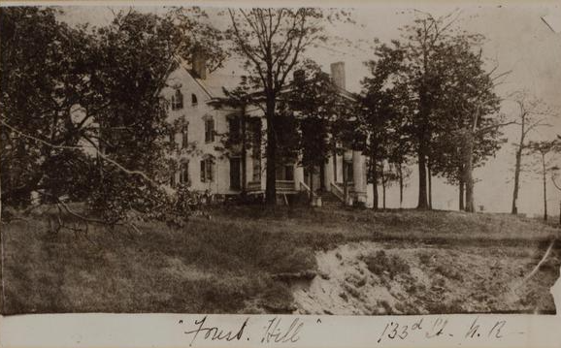
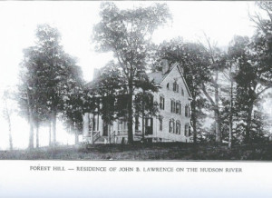

Location: near present 133rd St and Riverside Drive, Manhattan, New York.
Built: early nineteenth century.

Architectural Description
The Forest Hill house was a substantial mid-nineteenth-century country residence, probably erected in a restrained vernacular interpretation of the Greek Revival style that was common on Hudson River estates between the 1830s and 1850s.

The structure appears to have been two-and-a-half to three stories in height, constructed of light-colored masonry or painted brick. Its form consisted of a rectangular main block with symmetrical massing. The roof was a moderately pitched side-gable, with tall chimneys rising at the gable ends, indicating multiple interior fireplaces and suggesting that the house was suitable for year-round occupation even though it functioned primarily as a summer residence.
The principal façade was arranged with regular window spacing along a central axis. Tall, vertically proportioned sash windows were aligned evenly across the stories, reinforcing the classical balance of the design. At the center stood a columned portico or porch, probably supported by simple square or slightly tapered columns carrying a shallow pediment or roof. This feature emphasized the entrance and conveyed a degree of architectural dignity without elaborate ornament.
The house occupied a slightly elevated site overlooking the Hudson River and was surrounded by mature woodland. Contemporary images emphasize the heavily wooded setting: large deciduous trees partially frame and obscure the building, underscoring both its physical isolation and the still-forested character of upper Manhattan in the early nineteenth century. Rather than formal gardens or rigid landscaping, the house appears to have been set within a naturalistic environment consistent with the picturesque landscape ideals of the period.
History
Forest Hill was the summer residence of John Burling Lawrence, situated on a wooded rise overlooking the Hudson River in what was then the rural northern portion of Manhattan. During the period of Lawrence family ownership the surrounding land remained largely undeveloped. A nearly continuous forest stretched from the property northward toward the tip of Manhattan Island, giving the estate its name and preserving a distinctly rural atmosphere despite its relative proximity to the expanding city.

Forest Hill served as a seasonal retreat for the Lawrence family during the first half of the nineteenth century, when upper Manhattan was still sparsely settled and characterized by country estates and farmland. The Hudson River corridor attracted merchants, professionals, and intellectuals who sought country houses within convenient distance of New York City.
During the period of Lawrence residence, the naturalist and artist John James Audubon acquired a nearby estate of roughly twenty acres extending from West 155th to West 158th Streets west of Broadway. This placed Forest Hill within a small informal community of Hudson River country seats occupied by individuals connected through social, scientific, and cultural interests.
Natural History and Associations
George Newbold Lawrence, the distinguished American ornithologist and son of John Burling Lawrence, spent many summers at Forest Hill. The property lay directly beneath one of the major migratory bird routes along the Hudson River. From this advantageous vantage point Lawrence conducted numerous observations of birdlife, noting the movements and seasonal appearances of species that later informed his scientific work.

While residing at Forest Hill he developed close friendships with Victor Audubon and John Woodhouse Audubon, the sons of John James Audubon. These relationships linked the Lawrence and Audubon families through shared scientific interests and helped establish the Hudson River estates of upper Manhattan as an early setting for American ornithological observation and collaboration..
Later Development
The Forest Hill property was eventually absorbed into the urban grid as Manhattan expanded northward in the late nineteenth century. The site is now occupied by residential development near West 133rd Street and Riverside Drive, with no visible remains of the original house or landscape.
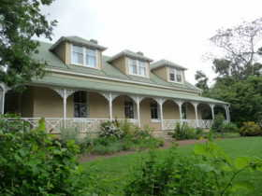
Formosa

Location: in northern Tasmania (then Van Diemen’s Land), Australia, situated on the Lake River near the present-day town of Cressy, within the Northern Midlands region south of Launceton.

Built: c. 1826.

Origins and Land Grant
Formosa was established by William Effingham Lawrence (1781–1841), an English merchant and colonist and son of Captain Effingham Lawrence. Lawrence arrived in Van Diemen’s Land in February 1823 aboard his own cutter, Lord Liverpool, carrying instructions from the British Colonial Office authorizing a substantial land grant.

By official order, Lawrence and his brother were to receive 4,000 acres each, with a reserve of a further 4,000 acres after five years, contingent on the land being “exclusive of waste land,” meaning land suitable for productive use rather than swamps, rocky ground, or other unusable terrain. The intention was therefore an eventual grant of 8,000 acres under strict conditions.

Controversy Over the Grant
Owing to mismanagement and errors by the Surveyor General’s office, the land surveyed and allocated to Lawrence ultimately amounted to approximately 12,000 acres (about 49 km²). The size of the grant caused considerable controversy within the small colonial society, where such extensive holdings were politically sensitive.

When Lieutenant-Governor Colonel George Arthur arrived in the colony in 1824, he was informed of the excessive acreage and ordered an official inquiry. John Helder Wedge, a government surveyor, was sent to re-survey the property. The investigation confirmed the boundaries of Lawrence’s grant along the Lake River, and although the process drew scrutiny, the enlarged holding was effectively allowed to stand.
Formosa was only one component of Lawrence’s extensive Tasmanian landholdings; in total, he ultimately received approximately 80 square miles of land across multiple grants.

Development of the Estate
Lawrence named the property Formosa, a name possibly inspired by the island of Formosa (Taiwan) or derived from the Latin or Portuguese sense of “beautiful.” A first log homestead was erected on the estate in 1824. In 1826, this building was destroyed by fire, reportedly set by bushrangers associated with Matthew Brady, who was known to harbor a personal grievance against Lawrence.

Following the destruction of the initial dwelling, Lawrence constructed a larger and more permanent homestead. Formosa developed into a major pastoral estate devoted primarily to sheep and cattle grazing, consistent with early patterns of settlement and land use in northern Tasmania.

Family and Management
Formosa played a central role in the Lawrence family’s Tasmanian enterprises. Lawrence’s eldest son, Robert William Lawrence (1807–1833), regarded as one of Tasmania’s pioneering botanists, managed the estate for a period. He died at Formosa at a young age, possibly as the result of an epileptic seizure. Other sons of William Effingham Lawrence continued pastoral operations at Formosa and at related family properties.

Beyond Formosa, Lawrence acquired numerous additional estates, including Billopp (approximately 2,000 acres near Formosa), Point Effingham (over 9,000 acres on the Tamar River), Vermont, Penquite, and other holdings around Launceston. Collectively, these properties made him one of the most substantial private landowners in the colony.

Foxhall Farms (also known as Loafer’s Lodge and Andor Farms)
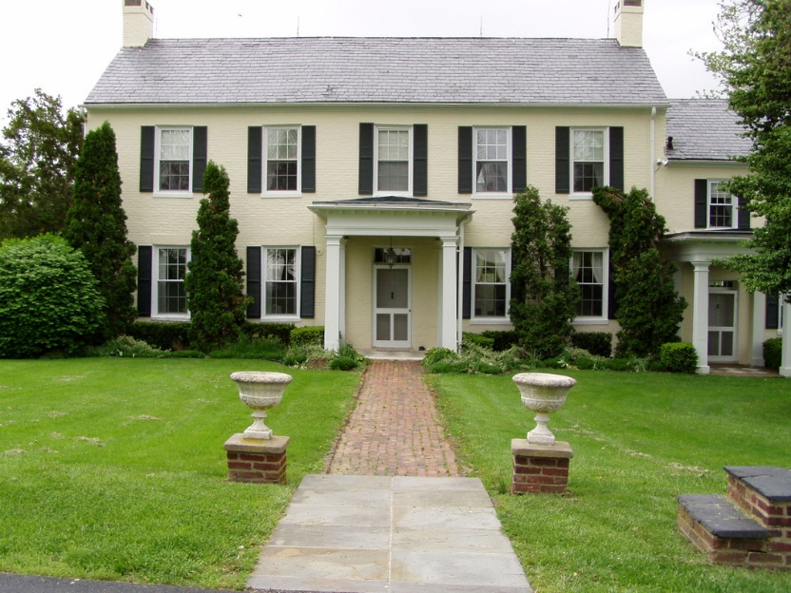
Location: 3509 Houcks Mill Road, Monkton, Maryland.
Built: c. 1919

Exterior and Interior
The house at Foxhall Farms (now Andor Farm) is a substantial early-20th-century country residence, sober and classical in character rather than ostentatious, well suited to Maryland hunt country. The exterior presents a long, symmetrical façade with a central entrance, restrained classical detailing, and a low, spreading roofline that emphasizes horizontality and permanence. Set within rolling pastureland, the house was designed to look outward toward the hunt country, functioning as a commanding yet comfortable sporting seat rather than a showplace mansion.
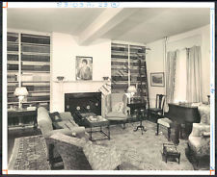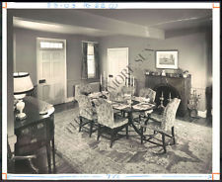
The interior was planned for hospitality and large gatherings, with generous public rooms, high ceilings, and fireplaces that made the house equally suitable for winter hunt weekends and large entertainments. Period photographs show spacious living and dining rooms furnished in a conservative country-house style, emphasizing comfort, durability, and sociability over formality. These interiors supported Foxhall P. Keene’s legendary house parties and race-day gatherings, reinforcing the house’s role as both a domestic residence and the social heart of the Foxhall Farm sporting world.
History
In 1919 the estate was purchased by Foxhall Parker Keene (1867–1941), one of the most celebrated American sportsmen of the late Gilded Age and early twentieth century. Keene was an eight-time national polo champion, an Olympic gold medalist in polo at the 1900 Paris Games, a Thoroughbred owner and breeder, an accomplished foxhunter, and an international sporting figure who maintained residences in England (notably near Melton Mowbray) as well as in the United States. He named the Monkton property Foxhall Farms after himself and developed it as a country house devoted primarily to equestrian pursuits rather than agricultural production alone.
The house functioned as a social and sporting center. Keene was known for large house parties and lavish hospitality; on one occasion, when the house caught fire while he was entertaining twenty-eight guests, the guests themselves reportedly helped extinguish the blaze. The estate became emblematic of the Edwardian sporting lifestyle transplanted to Maryland hunt country, blending elite leisure, horses, and spectacle.
After Keene’s active ownership period, the property passed through several hands and acquired the informal name Loafer’s Lodge, reflecting the recreational and sporting culture of the area. In the later twentieth century it became known as Andor Farm, a name attributed to owners Barbara and Henry Obre (derived, humorously, from checks made out to “Barbara and/or Henry Obre”). In the twenty-first century the property has operated as Andor Farm LLC, a working equestrian facility focused on breeding, training, and hunt-country sport, with long associations to Maryland horse families and trainers, including the Pickett family. The historic house and landscape remain integral to the identity of the farm amid continued equestrian use.

The Foxhall Farm Cup Team Chase
Foxhall Farms achieved national sporting renown through the creation of the Foxhall Farm Trophy Team Chase, inaugurated by Foxhall P. Keene in 1920. Conceived as a timber race run over natural hunt country, the event was intended to promote foxhunting skills, encourage point-to-point participation, and develop both horses and riders in true hunt fashion. Unlike conventional races, it was a team chase, with hunt teams starting together and galloping over a long cross-country course of roughly four to four-and-a-half miles, negotiating numerous stout timber fences.

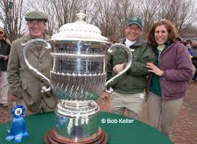
The inaugural running was a major social event. Keene hosted a party for approximately 700 guests on the eve of the race, underscoring the blend of sport and spectacle that characterized the occasion. Thousands attended the race itself, which drew teams from recognized hunt clubs and was described as thrilling, chaotic, and distinctly amateur in spirit. Central to the event was the Foxhall Farm Cup, a massive sterling silver trophy—one of the largest in American sport—holding approximately 82 quarts and weighing around 50 pounds, engraved over time with the names of winning teams.
After its early prominence, the race lapsed for decades, becoming part of hunt-country legend rather than an annual fixture. Its revival in the modern era reaffirmed its cultural importance. In 2006, the race was celebrated again at the property—by then known as Andor Farm—accompanied by a consciously historical, Gatsby-era themed party hosted by the contemporary owners, evoking Keene’s original festivities. The original Foxhall Cup was displayed alongside historical photographs documenting the race’s origins.
Since its revival, the Foxhall Farm Cup Team Chase has been held periodically, often as an early-season highlight in Maryland’s timber racing calendar. It is closely associated with the Elkridge-Harford Hunt and draws teams from Maryland, Pennsylvania, Virginia, and beyond. Recent runnings have featured courses of approximately four miles with twenty-six or more timber fences, and the event is widely regarded as a living survival of Gilded Age steeplechasing traditions—hunt-oriented, amateur, and communal—distinct from more formal fixtures such as the Maryland Hunt Cup.
Today, while Andor Farm functions as a modern working horse farm, the Foxhall Farm Cup endures as a symbolic link between contemporary Maryland hunt country and the grand sporting culture established there by Foxhall Parker Keene in the early twentieth century.

